Quiz_Lecture24

Name：刘承奇 Student ID：2018533249



1. Give an optimal policy for the above problem;

One optimal policy:

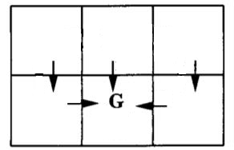

1. Calculate the  values;

 values:

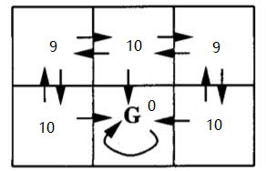

1. Calculate the  values.

 values:

